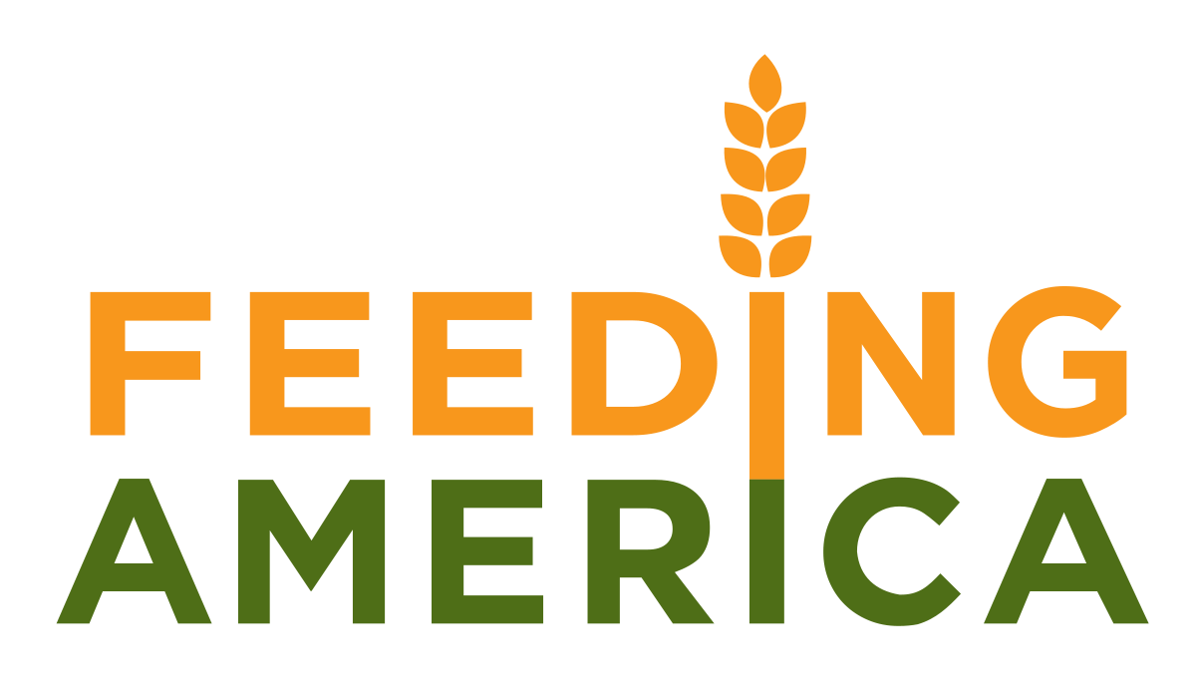

Lambda Chi Alpha Fraternity

Iota Theta Zeta Chapter

Arkansas State University

P.O. Box 926

# State University, AR 72467

**Sandblast Volleyball Tournament**

**Saturday, April 14, 2018 @ 10AM, Lambda Chi Alpha House**

**Benefitting Feeding America and the A-State Food Pantry**

On Saturday, April 14th, Lambda Chi Alpha fraternity will host the annual Sandblast Volleyball Tournament with all proceeds benefitting Feeding America. For over a decade, teams representing organizations across the Arkansas State University Campus, as well as those from surrounding communities have participated in this event to support hunger relief.

Each year, the generosity of local businesses and community leaders help us in our efforts to support Feeding America, and this year, we have set our goal to raise $4,000 worth in donations or during the event. Your sponsorship for advertisement space on the event t-shirts and banner will help us in achieving this goal. All donations to the event are tax deductible as 100% of proceeds benefit Feeding America, and a proof of philanthropic activity can be emailed to donors by robert.morris@smail.astate.edu.

**Sponsorship Levels and Advertisement:**

**$100** – Name/Logo on event t-shirts

**$250** – Name/Logo on event t-shirts and event banner

**$500** – Presenting sponsor, which will be mentioned in all press releases, interviews, etc.

We are currently searching for businesses that will donate **raffle prizes** for advertisement as well.

\**Donations or Sponsorship through event materials or non-monetary contribution welcomed. If these advertisement options do not seem viable for your business, other options are up for discussion.*

**\*Please provide any logos or artwork that you would like included in your advertisement or email them to** [robert.morris@smail.astate.edu](mailto:robert.morris@smail.astate.edu).

Should you have any questions, please do not hesitate to contact me any time at 501-827-9062 or [robert.morris@smail.astate.edu](mailto:robert.morris@smail.astate.edu). Your support is much appreciated!

Sincerely,

Robert Morris, External Vice President

Lambda Chi Alpha – Iota Theta Zeta Chapter

**2018 Sandblast Volleyball Tournament Sponsorship Form**

Business Name: _____________________________________________________

Address: ___________________________________________________________

City: ____________________________ State:_______ Zip:__________________

Phone: ________________________Contact Person: _______________________

*Please provide us with any logos or artwork you would like included with your advertisement. Artwork can be emailed to* [*robert.morris@smail.astate.edu*](mailto:robert.morris@smail.astate.edu) *or submitted with this form.*

*Did you hear about our event from a Chapter Member? If so, please print their name below:*

______________________________________  
  
*Artwork Attached:* Y / N *Payment Attached*: $_________

* **100** – Name/Logo on event t-shirts
* **$250** – Name/Logo on event t-shirts and event banner
* **$500** – Presenting sponsor, which will be mentioned in all press releases, interviews, etc.
* We are currently searching for businesses that will donate **raffle prizes** for advertisement as well.

\**Donations or Sponsorship through event materials or non-monetary contribution welcomed. If these advertisement options do not seem viable for your business, other options are up for discussion.*